System: Effectively Think Cloud (EThink Cloud)

Requested By: Ramazan Director of “Effectively Think Corp”

Purpose:

The purpose of the Think project is to provide a comprehensive platform that facilitates efficient management of client accounts, offers personalized tariff management, and ensures secure access to services through API integration. This project aims to streamline the registration and authentication processes for both personal and commercial clients, while also enabling seamless management of company accounts. By offering a user-friendly developer portal, EThink empowers developers to access necessary API documentation, test functionalities, and create applications seamlessly. Additionally, the project focuses on optimizing backend systems, ensuring reliable performance, and integrating with various cloud services for enhanced scalability and functionality. Through careful orchestration of workflows and integration with high-performance computing servers where necessary, EThink endeavors to deliver a robust and versatile solution catering to diverse user needs

UML user case

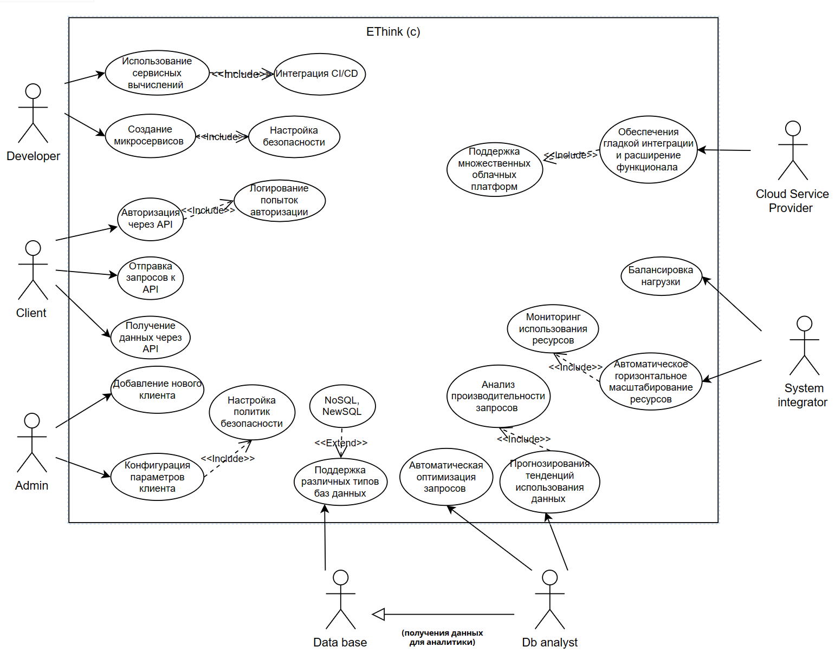

Data Flow Diagram

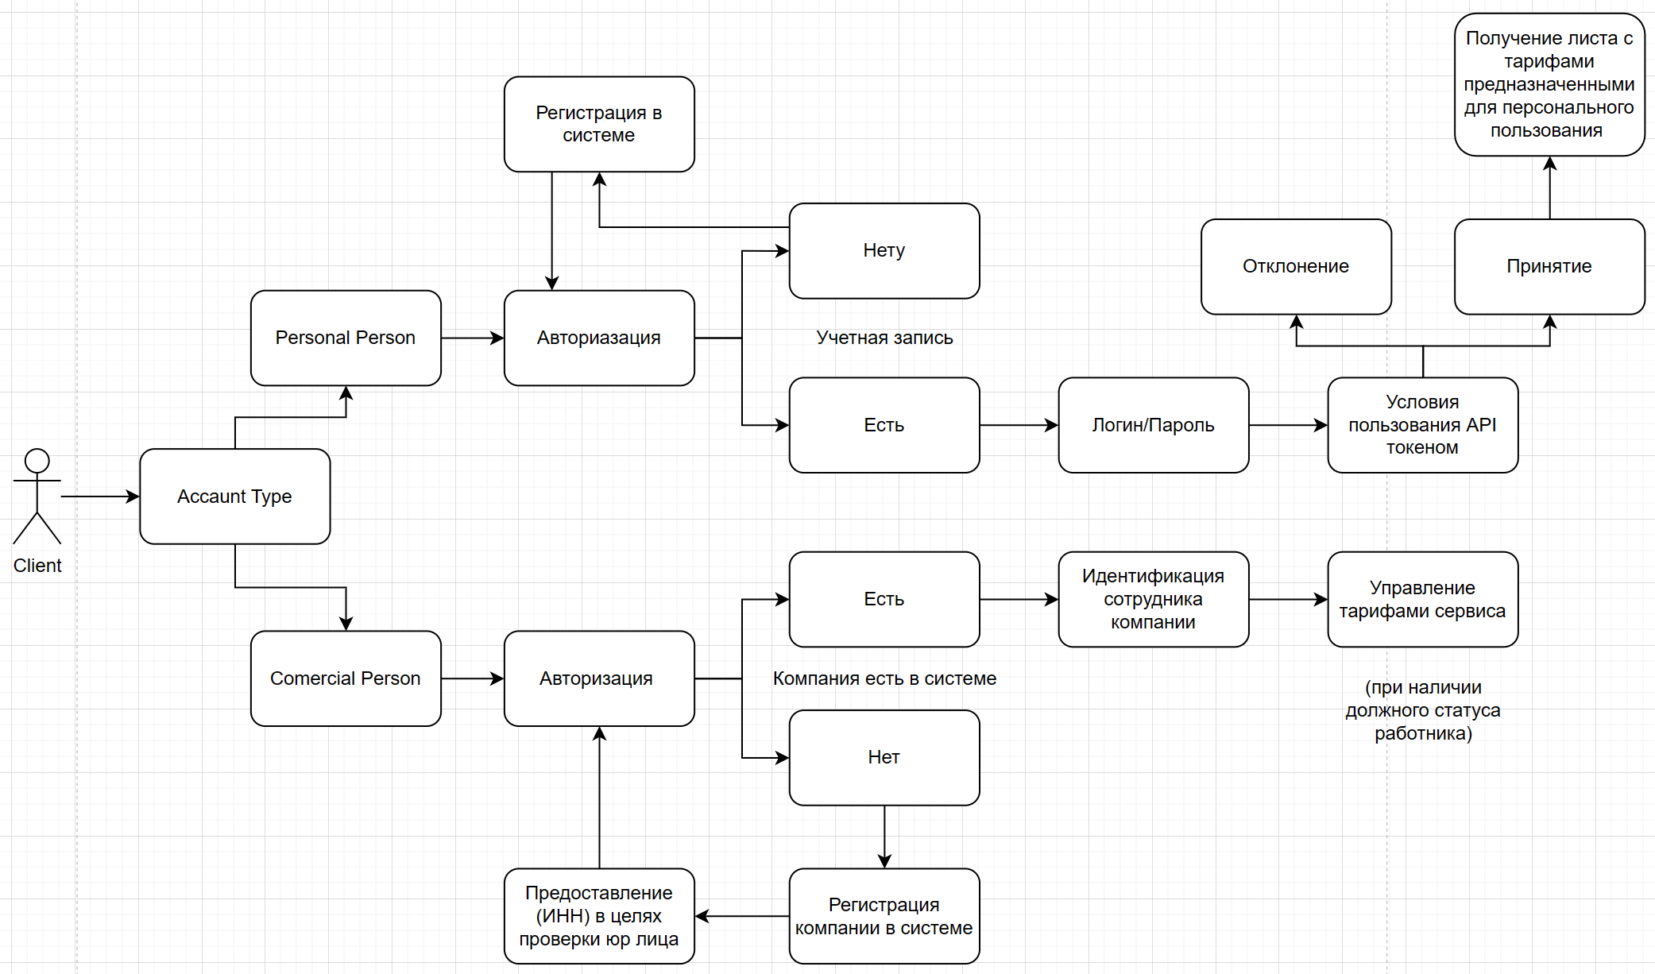

System Architecture Diagram

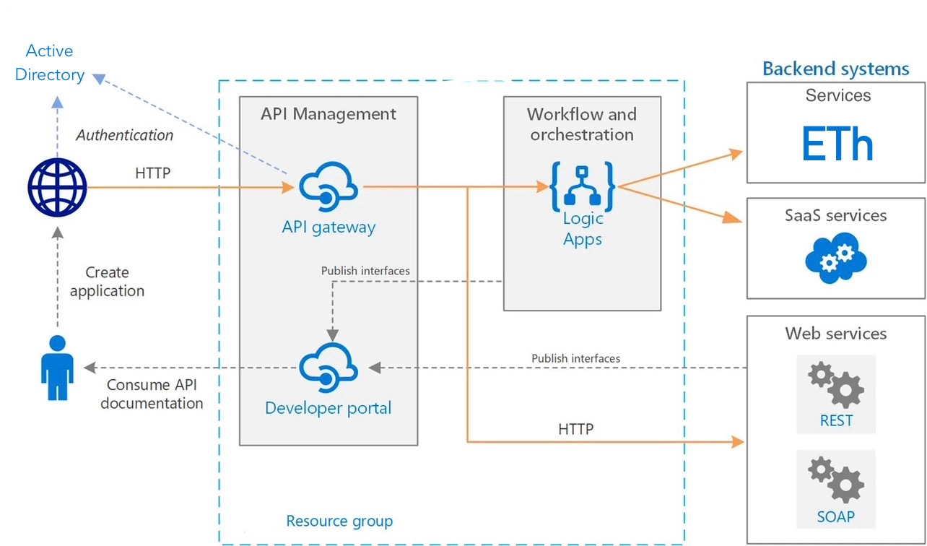

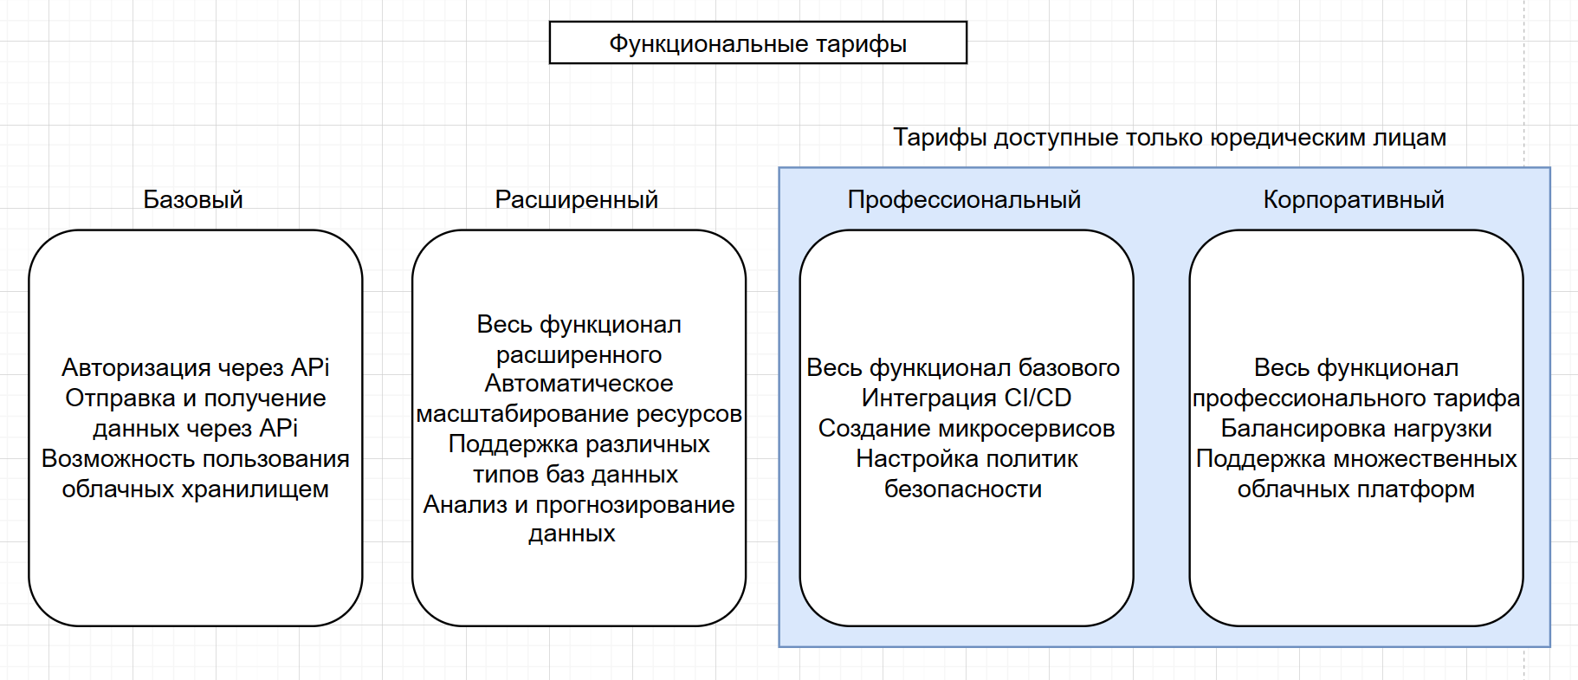

Deployment diagrams

